Web Application Development Lab 04 Report
Student Name: Vũ Quốc Khánh
Student ID: ITCSIU24039

Exercise 1

Task 1.2

Code
<%--
Document : list_students
Created on : Apr 22, 2026, 2:16:39 PM
Author : islabre
--%>

<%@page contentType="text/html" pageEncoding="UTF-8"%>
<%@ page import="java.sql.*" %>
<!DOCTYPE html>
<html>
<head>
<meta http-equiv="Content-Type" content="text/html; charset=UTF-8">
<title>Student Info</title>

<style>
table, td {
border: 1px solid;
border-collapse: collapse;
}

td {
padding: 0.25em;
}
</style>
</head>
<body>
<h1>Student Info</h1>

<% if (request.getParameter("message") != null) { %>
<div class="message">
<%= request.getParameter("message") %>
</div>
<% } %>

<table>
<thead>
<td>ID</td>
<td>Student Code</td>
<td>Full Name</td>
<td>Email</td>
<td>Major</td>
<td>Created At</td>
</thead>
<tbody>
<%
Connection conn = null;
Statement stmt = null;
ResultSet rs = null;

try {
// Connect to database
Class.forName("com.mysql.cj.jdbc.Driver");

conn = DriverManager.getConnection(
"jdbc:mysql://localhost:3306/student_management",
"root",
"Q@jaP*96T8xY#2^7&3@7"
);

// Query for students
stmt = conn.createStatement();
String sql = "SELECT * FROM students";
rs = stmt.executeQuery(sql);

// Get info
while (rs.next()) {
int id = rs.getInt("id");
String studentCode = rs.getString("student_code");
String fullName = rs.getString("full_name");
String email = rs.getString("email");
String major = rs.getString("major");
Timestamp createdAt = rs.getTimestamp("created_at");
%>
<tr>
<td><%= id %></td>
<td><%= studentCode %></td>
<td><%= fullName %></td>
<td><%= email != null ? email : "N/A" %></td>
<td><%= major != null ? major : "N/A" %></td>
<td><%= createdAt %></td>
</tr>
<%
}
// Handle errors
} catch (ClassNotFoundException e) {
out.println("<tr><td colspan='7'>Error: JDBC Driver not found!</td></tr>");
e.printStackTrace();
} catch (SQLException e) {
out.println("<tr><td colspan='7'>Database Error: " + e.getMessage() + "</td></tr>");
e.printStackTrace();
// Close database connection
} finally {
try {
if (rs != null) rs.close();
if (stmt != null) stmt.close();
if (conn != null) conn.close();
} catch (SQLException e) {
e.printStackTrace();
}
}
%>
</tbody>
</table>
</body>
</html>

Result
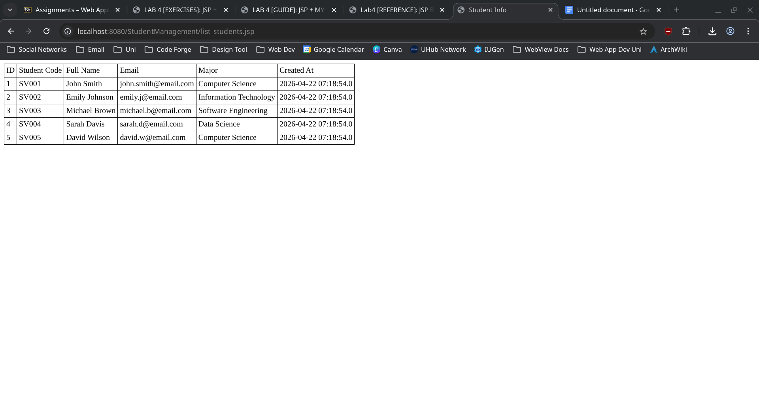

Exercise 2

Task 2.1

Code
<%--
Document : process_add
Created on : Apr 22, 2026, 2:56:45 PM
Author : islabre
--%>

<%@page contentType="text/html" pageEncoding="UTF-8"%>
<!DOCTYPE html>
<html>
<head>
<meta http-equiv="Content-Type" content="text/html; charset=UTF-8">
<title>Add Student</title>
</head>
<body>
<h1>Add Student</h1>

<% if (request.getParameter("message") != null) { %>
<div class="message">
<%= request.getParameter("message") %>
</div>
<% } %>

<form method="POST" action="process_add.jsp">
<table>
<tr>
<td>Student Code</td>
<td>
<input type="text" name="student-code" id="student-code" required>
</td>
</tr>
<tr>
<td>Full Name</td>
<td>
<input type="text" name="full-name" id="full-name" required>
</td>
</tr>
<tr>
<td>Email</td>
<td>
<input type="email" name="email" id="email">
</td>
</tr>
<tr>
<td>Major</td>
<td>
<input type="text" name="major" id="major">
</td>
</tr>
<tr>
<td></td>
<td>
<input type="submit" value="Submit">
<a href="list_students.jsp">
<button type="button">Cancel</button>
</a>
</td>
</tr>
</table>
</form>
</body>
</html>

Result
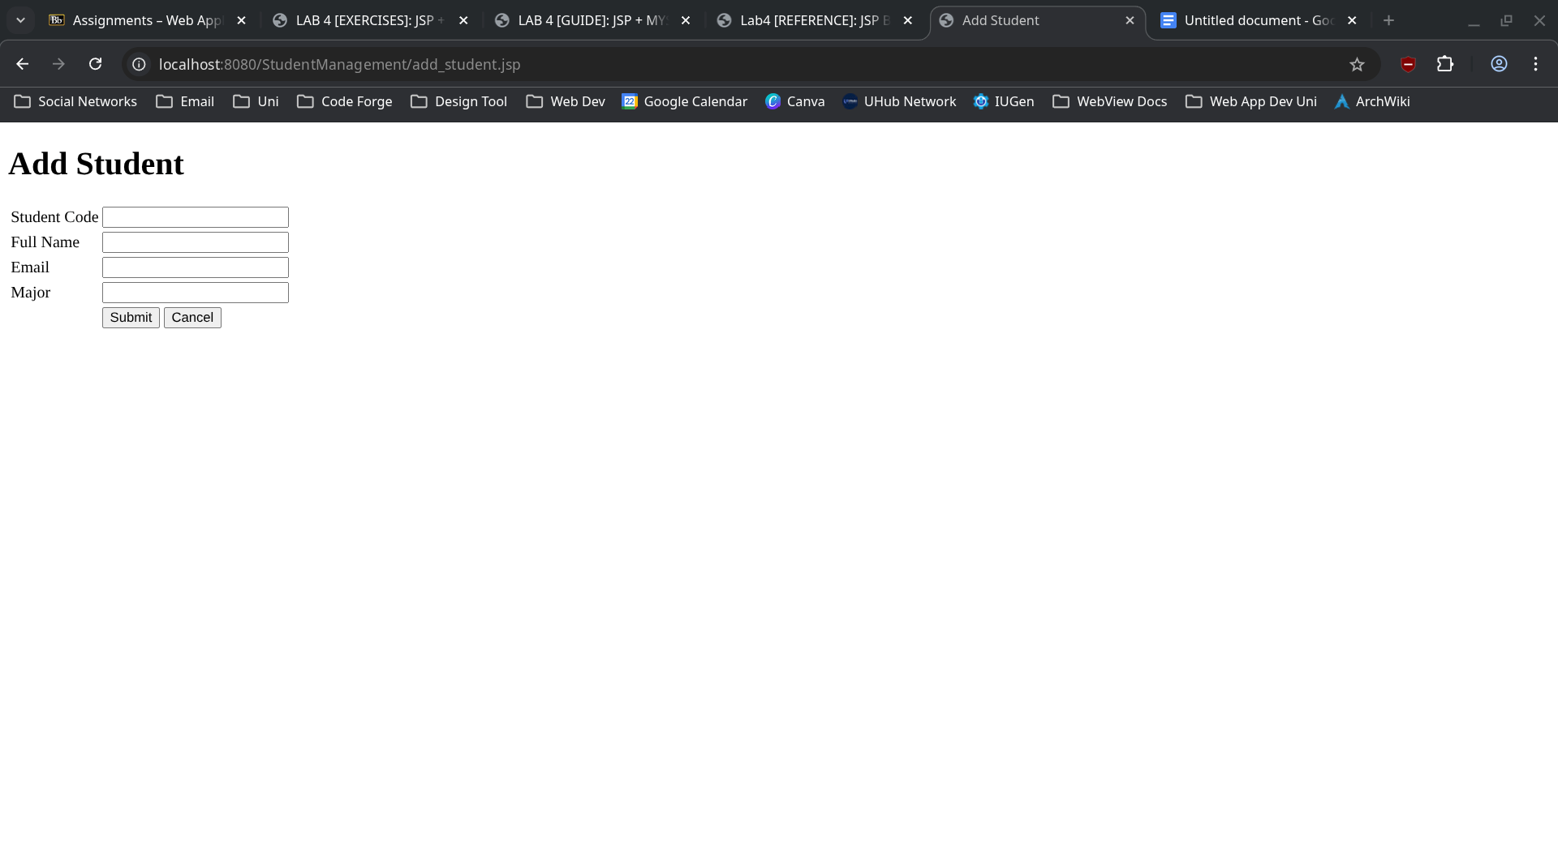

Task 2.2

Code
<%--
Document : process_add
Created on : Apr 22, 2026, 3:13:22 PM
Author : islabre
--%>

<%@page contentType="text/html" pageEncoding="UTF-8"%>
<%@ page import="java.sql.*" %>
<!DOCTYPE html>
<html>
<head>
<meta http-equiv="Content-Type" content="text/html; charset=UTF-8">
<title>Student Adding Process</title>
</head>
<body>
<%
String studentCode = request.getParameter("student-code");
String fullName = request.getParameter("full-name");
String email = request.getParameter("email");
String major = request.getParameter("major");

if (studentCode == null || studentCode.trim().isEmpty() ||
fullName == null || fullName.trim().isEmpty()) {
response.sendRedirect("add_student.jsp?message=Error: Required fields are missing.");
}

Connection conn = null;
PreparedStatement pstmt = null;

try {
// Connect to database
Class.forName("com.mysql.cj.jdbc.Driver");

conn = DriverManager.getConnection(
"jdbc:mysql://localhost:3306/student_management",
"root",
"Q@jaP*96T8xY#2^7&3@7"
);

// Insert info into database (prepare statement first to prevent SQL Injection Attack)
String sql = "INSERT INTO students (student_code, full_name, email, major) VALUES (?, ?, ?, ?)";

pstmt = conn.prepareStatement(sql);
pstmt.setString(1, studentCode);
pstmt.setString(2, fullName);
pstmt.setString(3, email);
pstmt.setString(4, major);

int rowsAffected = pstmt.executeUpdate();

if (rowsAffected > 0) {
response.sendRedirect("list_students.jsp?message=Student added successfully");
} else {
response.sendRedirect("add_student.jsp?message=Error: Failed to add student");
}

// Handle errors
} catch (ClassNotFoundException e) {
response.sendRedirect("add_student.jsp?message=Error: JDBC Driver not found.");
e.printStackTrace();
} catch (SQLException e) {
String errorMsg = e.getMessage();
if (errorMsg.contains("Duplicate entry")) {
response.sendRedirect("add_student.jsp?message=Error: Student code already exists");
} else {
response.sendRedirect("add_student.jsp?message=Error: Database error");
}
e.printStackTrace();

// Close database connection
} finally {
try {
if (pstmt != null) pstmt.close();
if (conn != null) conn.close();
} catch (SQLException e) {
e.printStackTrace();
}
}
%>
</body>
</html>

Result
Adding a student via add_student.jsp:
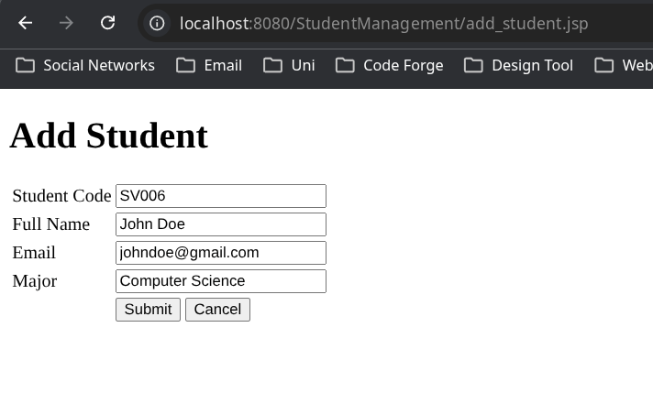
After adding:
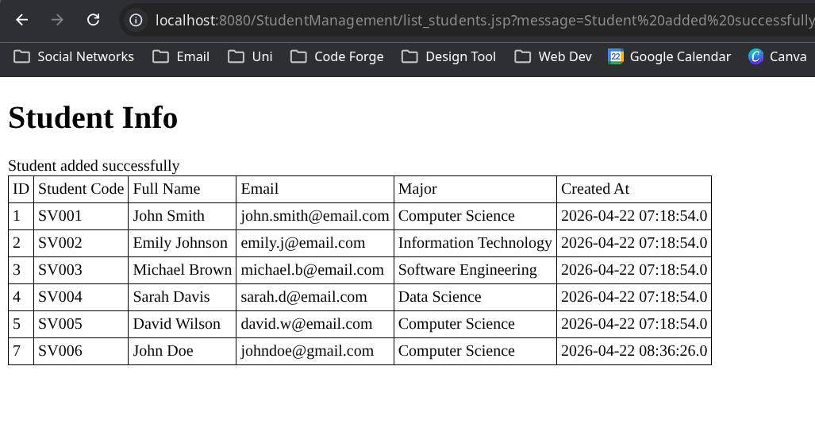
Try to add a student with empty Student Code (handled by the browser itself):
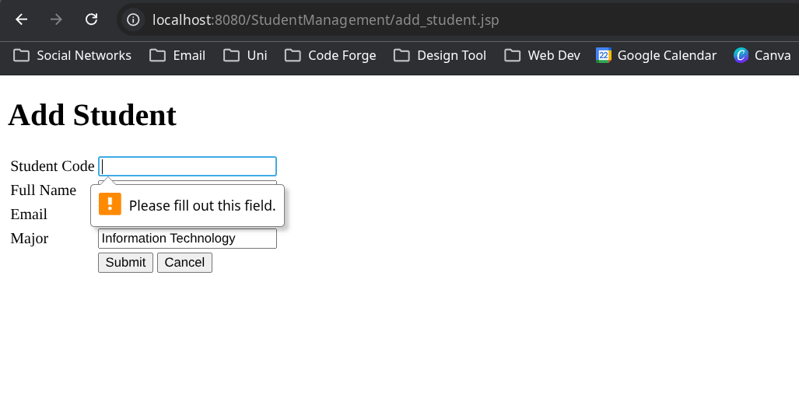
Try to add a student using existing Student Code:
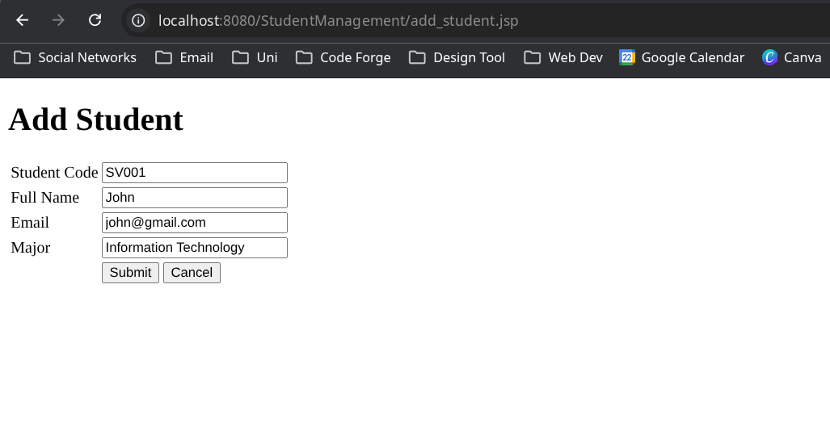
Result:
